Guide to APA Formatting
How to tackle your APA paper!
Contents
- APA Title Page Basic Guidelines
Explaining the format of a Title page.

- APA Basic Guidelines
First step of formatting with APA.

- APA Reference Page
Explaining a Works Cited page.

- APA In-Text Citations
How to reference sources within the paper.

- APA Citations Charts: Books, Periodicals, Electronic Sources
Easy to use charts to guide you through the citation process.

- Sample copy of APA Research Paper
See an example of a paper in APA format.

- Title Page
Make sure to create a title page that goes before your actual paper.
Format:
- Make sure this page is by itself.
- The running page number and header should not begin on this page.
- 3-4 lines down, put the paper’s title, bolded and center aligned.
- Skip a line, then put the other content information, each on its own line.
Content:
- The title of the paper
- Student’s name
- Professor’s name
- Course title
- The name of the university
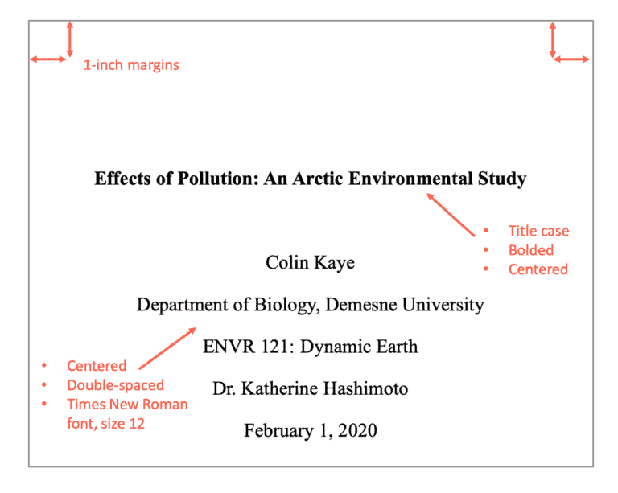
- Due date

Example:

Guidelines
Formatting:
Make sure to follow these formatting rules when writing your APA paper.
- Leave margins of 1 inch at the top bottom, and both sides of the paper.
- Use an easily readable font (usually Times New Roman).
- Use a 12 point font.
- Use the same typeface and type size throughout the paper.
- Double space the paper.
Title:
Make sure to set up your title in the correct APA format.
- In the heading, right indented, put the page number.
- On the first line, center aligned, put the title of the paper.

Example:
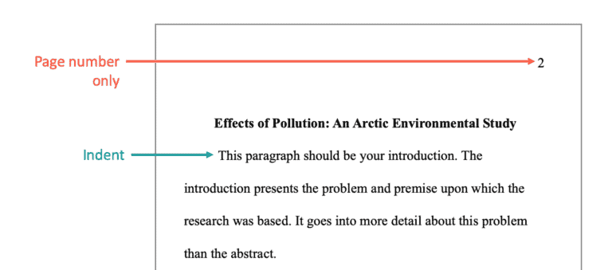

3. Reference Page
Make sure to keep track of your sources by beginning the reference page at the beginning of the writing process!
Format:
- Make sure this page is by itself.
- The running page number and header should continue.
- Make sure the sources are alphabetized.
- Make sure the first line of each entry is left aligned.
- If the entry is more then one line make sure the lines after the first are indented.
- Make sure everything is double spaced.
*To see how to cite individual sources for each type of source on the reference page, go to the APA citations chart in this packet or look at the APA Handbook, 7th Edition*

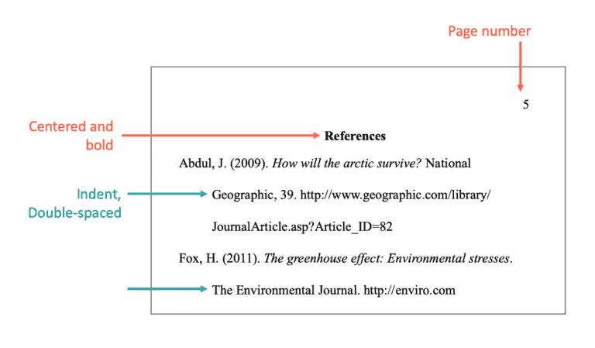
Example:
4. APA In-Text Citations
Make sure that each of your entries are formatted correctly within the paper.
Parenthetical Citations
- At the end of the sentence, before the period, put the author’s last name and the page number in parentheses.
- Example: Jack hit a ball over the hill (James, 24).

If there is no page number, just put the last name.
If there is no author, put the first part of your citation with the page number.

If you start your sentence acknowledging the author, just put the page number in the parentheses.
- Example: James says in his writing that Jack hit a ball over the hill (24).
If there are two authors, make sure to include both. If there are three or more authors, abbreviate with the first name and then “et. al.”

5. APA Citation Charts
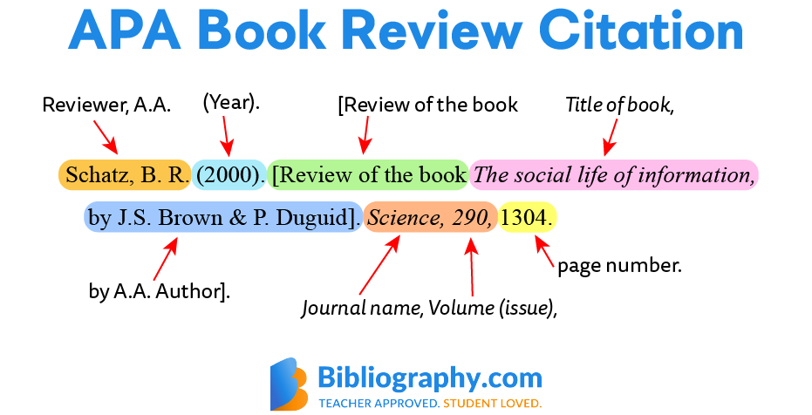
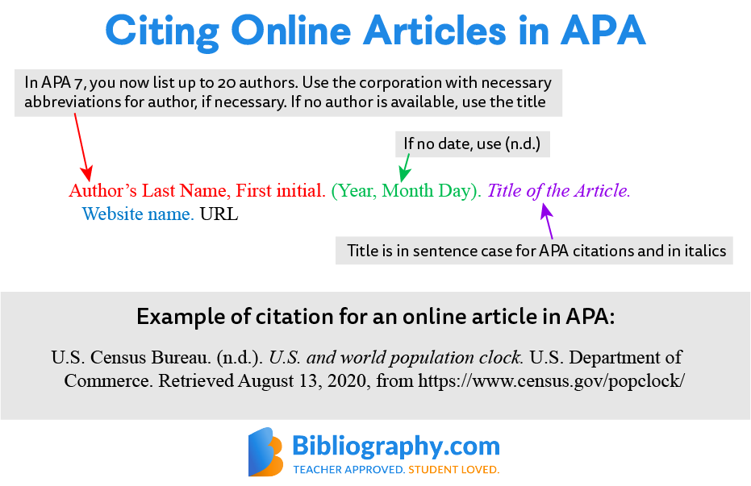

6. Example APA Papers

Links to example papers:
- https://owl.purdue.edu/owl/research_and_citation/apa_style/apa_formatting_and_style_guide/apa_sample_paper.html
- https://apastyle.apa.org/style-grammar-guidelines/paper-format/sample-papers
- https://www.easybib.com/guides/citation-guides/apa-format/apa-sample-paper/

*information for this packet was compiled from Purdue Owl as well as other online resources.*

