Guide to MLA Formatting
How to tackle your MLA paper!
Contents
- MLA Basic Guidelines
First step of formatting with MLA.

- MLA Works Cited
Explaining a Works Cited page.

- MLA In-Text Citations
How to reference sources within the paper.

- MLA Citations Charts: Books, Periodicals, Electronic Sources
Easy to use charts to guide you through the citation process.

- Sample copy of MLA Research Paper
See an example of a paper in MLA format.

Guidelines
Formatting:
Make sure to follow these formatting rules when writing your MLA paper.
- Leave margins of 1 inch at the top bottom, and both sides of the paper.
- Use an easily readable font (usually Times New Roman).
- Use a font between 11 and 13 points.
- Use the same typeface and type size throughout the paper.
- Double space the paper.
Title:
Make sure to set up your title in the correct MLA format.
- In the heading, right indented, put your last name and page number.
- Your name on the top line, left indented.
- Teacher’s name on the second line, left indented.
- Course name and number on the third line, left indented.
- Date on the fourth line, left indented.

Example:
- Works Cited
Make sure to keep track of your sources by beginning the Works Cited page at the beginning of the writing process!
Format:
- Make sure this page is by itself.
- The running page number and header should continue.
- Make sure the sources are alphabetized.
- Make sure the first line of each entry is left aligned.
- If the entry is more then one line make sure the lines after the first are indented.
- Make sure everything is double spaced.
*To see how to cite individual sources for each type of source on the Works Cited page, go to the MLA citations chart in this packet or look at the MLA Handbook, 9th Edition*

Example:
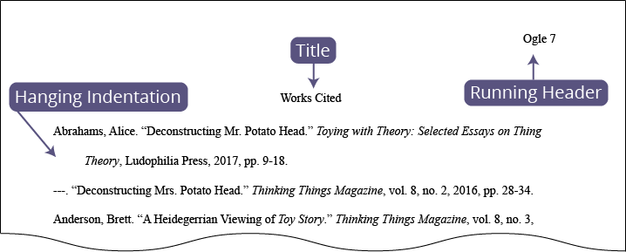

- MLA In-Text Citations
Make sure that each of your entries are formatted correctly within the paper.
Parenthetical Citations
- At the end of the sentence, before the period, put the author’s last anime and the page number in parentheses.
- Example: Jack hit a ball over the hill (James, 24).

If there is no page number, just put the last name.
If there is no author, put the first part of your citation with the page number.

If you start your sentence acknowledging the author, just put the page number in the parentheses.
- Example: James says in his writing that Jack hit a ball over the hill (24).

- MLA Citation Charts
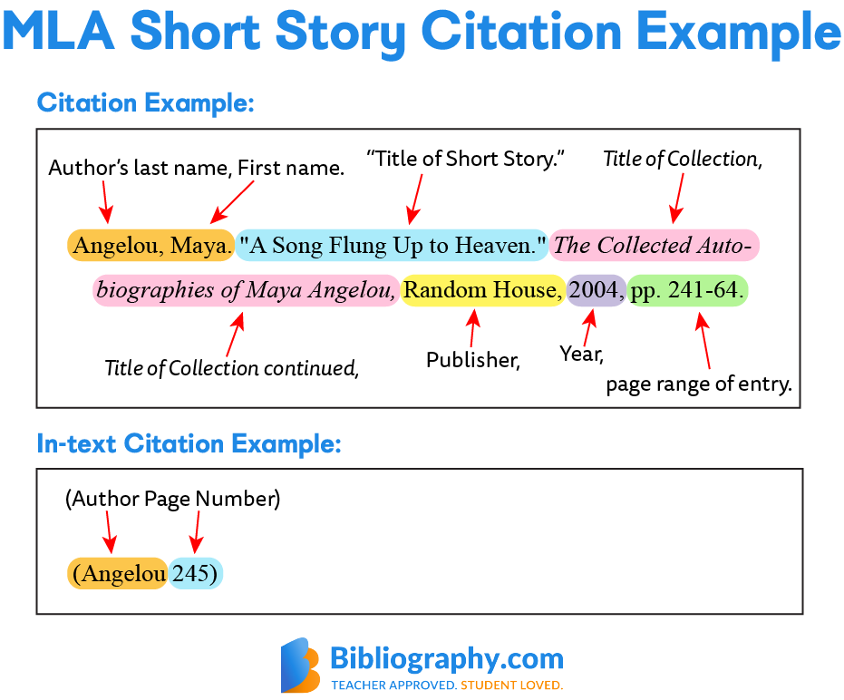
-from bibliography.com
- Example MLA Paper from Purdue Owl

Links to example papers:
- https://owl.purdue.edu/owl/research_and_citation/mla_style/mla_formatting_and_style_guide/documents/20190822MLASamplePaper.pdf
- https://style.mla.org/sample-papers/
- https://www.easybib.com/guides/citation-guides/mla-format/sample-paper-mla/

